Ababacar S Diagne

12/15/21

Ignite Research

Dr. Davidson

Filtration of Nitrate in Farm Runoff

**Background Knowledge**

*Nitrate*

There are common nutrients that are used in crops to help them grow. They are also known as fertilizers. An indirect form of supporting the crops is the use of pesticides. which will not be addressed in this research paper. Naturally, the soil which farmers use already has basic elements. They can be numerous listing from sulfur, magnesium, calcium, iron, boron, zinc, and molybdenum[1]. However, farmers tend to add chemicals with outside sources. They consist of primarily three substances, phosphorus, potassium, and nitrogen. Each has its own way of improving plant growth. For instance, phosphorus aids the plant with two aspects. Firstly, it supports its ability to store energy and its ability to perform photosynthesis. This element is most commonly acquired from phosphate rocks. In terms of potassium, it gives plants the ability to fight diseases which not only protects other plants, but also the people who benefit from them. Additionally, potassium strengthens the plants during cold or dry seasons, making their roots strong.[2] The final chemical and arguably the most important element that farmers use, is nitrogen. Plants utilize this element to the greatest extent. They use it to make glucose from water and carbon dioxide. It also provides components for amino acids, which in short, are the building blocks to life. So why would any farmer or individual want such a chemical to be wasted? It is far too important to carelessly fertilize farms without incorporating the most efficient practices.

Figure : Images of plants without potassium, phosphorus or nitrogen (From Fertilizer 101 Big 3, October 32 2016)

*Midwest Soil and Precipitation Trends:*

The main focus of this paper will revolve around the element nitrogen. However, before understanding the methods of improving the efficiency in farming, the cause of its inefficiency will be outlined. This will mean that the aspects of both weather and soil type are extremely important. The Midwest provides more than 25% of the world’s food.[3] This is primarily due to the growth of corn, which has many applications such as plastic and biofuel. Besides being such a huge percentage of the world’s provider, the Midwest is also home to variety of soil types. These range from those with various textures consisting of different amounts of clay, silt, and sand.[4] In terms of precipitation, the Midwest tends to experience a number of anomalies in the weather.[5] In Figure 1, one can see that the anomalies have been far more common, which potentially means that the farming practices that previously worked, may not work in the future. This may be in terms of excess rain or extreme warm temperatures during the summer.

Figure : Soil texture triangle (from Lucas M.D, 2014

One must understand that it is difficult to control the amount of precipitation that goes into the crops. Ice and snow, which are other forms of water, have an impact on plant growth. In recent years, it seems that the growing season has been slowly extending, which is good. The longer a farmer has time to grow crops, the more likely they will produce high yield and also be able to grow a wider variety of plants. However, excess water cannot only destroy plants, but it could also wash away a lot of nutrients, which cost farmers in the form of lost fertilizer.[6] Based on Figure 2, one can see that the index for extreme weather is becoming far more common.

Figure : Annual temperature anomalies for the Midwest from the CRUTEM3 data set. The anomalies are relative to 1961- 1990. The data have a spatial resolution of 5 x 5° thus the domain used to construct this figure is 35°N to 50°N and 95°W to 80°W. Data were downloaded from http://www.cru/uea.ac.uk/cru/data/temperature/#datdow. Also shown is a 5 year running mean and linear fits to the annual data for 1900-2010, 1950-2010 and 1979-2010. The shading represents the 95% confidence intervals on the fits. The slopes of the region-wide trend estimates are expressed in °C per decade and are shown for 3 time periods; 1900-2010, 1950-2010, and 1979-2010 (Pryor and Barthelmie 2011a).

*Nitrogen Cycle:*

The movement of nitrogen, which is restricted or hastened from the two influencers above, moves through many processes, as illustrated by the nitrogen cycle, in Figure 3. This cycle is arguably started by the commercial fertilizing companies, then sent to farms, that use it in their crops, and then there are multiple chemical reactions that happen. Once this completed, the nitrogen enters the soil, where it may find its way to some major water source. This cycle implies that there is some nitrogen leaving the crops and entering into another aspect of life. This could be the lakes, rivers, or oceans.

Figure : Nitrogen cycle (from Nitrogen Cycle in Agriculture)

*Negatives of Farm Runoffs:*

At some point, the water source reaches the Mississippi river, which then leads to the Gulf of Mexico. In the Gulf of Mexico, there is a huge issue of nitrogen pollution.[7] This pollution has led to a dead zone where marine life cannot survive. One must understand that the efficiency of nitrogen in crops is not only important for increasing yield, but for also preventing a major decrease in marine life. This nutrient is not only found in the water that marine life swims in, but also the water that people drink from. The primary impact of nitrogen in fresh water its algae growth, which will have the same impact it had in the Gulf of Mexico on fish. However, the situation becomes far more dangerous because people are also at risk from ingesting it. In this research paper, the entire cycle will be rethought and the most important part in rethinking, will be the nitrogen leaching.

*Nitrogen Leaching and Common Practices:*

One example of nitrogen leaching is when precipitation and irrigation causes the various nutrients used in crops to be transported deeper into the soil profile.[8] The concentration of these chemicals may be high or low, depending on the timing of their placement or the severity in precipitation. It goes without saying that the higher the concentration, the more negatively it will likely impact the environment. This will follow the nitrogen cycle. However, the leaching process is somewhat of a process in itself.

In recent times there have been practices that have worked in terms of reducing the runoff. One of the more subtle ways to do this is to add soil content that is thicker, such as clay. As written in the analysis, the soil content has a huge impact on how fast water can travel within it. The slower the water travels down the soil, the more time the plant has to absorb the nutrients. One can assume an equation the thicker the soil the less the leaching.[9] Apart from this, another solution is building a subsurface drainage system underneath the crops and utilizing drainage water recycling.[10] This development is fairly recent, but it relocates the water filled with nitrate and moved it into an area.[11] In hopes of intercepting nitrate filled water before it reaches waterways. This method prevents and increases efficiency at the same time. Another solution is having cover crops, which is adding plants on top of the frozen soil.[12] These crops would absorb any left-over nutrition left post or pre harvesting.

These practices are one of many, however, with so many different types of soil combinations and weather circumstances it must ultimately be understood that there is no one way of resolving the issue of nitrogen leaching.[13]

**Nitrate Reduction Systems and Processes**

In a study from the University of Illinois at Urbana Champaign, by Christianson L.E, Frankenbergerc J., Hay C., Helmers M.J, and Sands G., they created a short list of 10 ways to reduce nitrate runoff. Their methodology is rather interesting, as they not only value the reduction of the runoff, but also implement ways to reuse the nitrogen. The method that these methods address is firstly reducing the nitrogen source, increasing plant uptake, reducing the amount of drainage or flow entering the stream, and increasing denitrification. For the sake of conciseness and limit of time, 6 of the different method will be analyzed and interpreted.

*Winter Cover Crop*

The name suggests all of the major aspect of winter cover crops. When the harvesting and growing season are over, there are crops that are grown on the fields throughout the winter. The way it works is simpler to the way farmers would plant crops.[14] When these crops are planted, they absorb nutrients from the soil in order to grow, which in most cased are effortless. These crops could be rye, rye grass, legumes, brassicas, alfalfa, hairy vetch, or clover.[15] Legumes are generally good at increasing organic microbes, increasing soil prosperity, and are even used to break pest cycles.[16] With these applications farmers can use all 365 days of the year for either preserving, preparing or growing their crops. In addition to legumes, grasses are a popular choice. They are known to hold nitrate, reduce erosion, suppress weeds and also conserve soil moisture.[17] This gives more reason to why cover crops are useful. Also, the grasses ability to suppress weeds is the most impressive. Traditionally, farmers had to pick them out and recently in the 21st century farmers use chemicals to kill them. The use of chemicals is always a difficult topic, due to the emerging stigma of potential ingestions of them. However, the use of grass is harmless and does not need explanation, on whether it can harm the crops. Lastly, rye crops are really effective in the reduction of nitrogen. In the table below, provided by “Ten Ways to Reduce Loads from Drained Cropland in the Midwest”, they show the percentage reductions in nitrogen leaching.[18] In some areas the cover crops were more effective, however the results suggest a successful pattern.

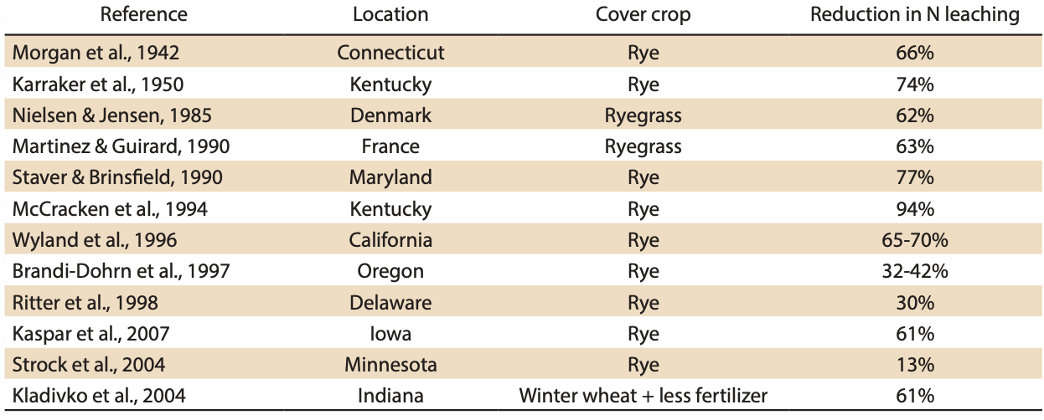

Figure : Reductions in nitrate­N leaching due to rye or ryegrass winter cover crops (from Kaspar et al., 2008).

*Recycling Drainage Water:*

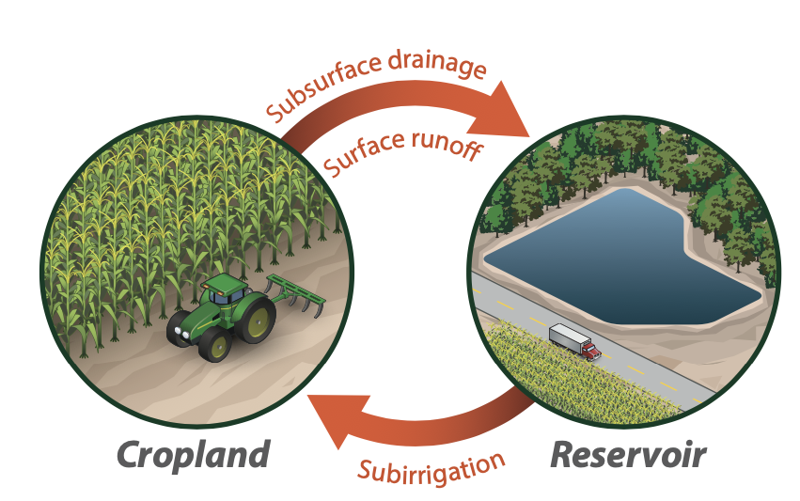 In this next management practice the scientist in the “Ten Ways to Reduce Nitrogen Loads from Drained Cropland in the Midwest”, suggest a recycling system. This system is re-routing the runoff from the crops into reservoirs. This method in most cases require some construction. Which entails of an initial construction and an infrastructure investment. The construction component is simply taking a portion of the land out of production and making it into a reservoir, then the infostructures component is moving the runoff water to the reservoir or back.[19] The reapplications of the water filled with so much nutrition is a very interesting. The idea of reusing the water means that not only the chemicals would not be wasted into water bodies is ingenious. This would save a large number of marine lives. Additionally, this would also improve the yield that farmers produce. They would have additional fertilizer to put into their crops, which can save them lot of money in the long run. One aspect of this method that is unsettling is the different slopes of land that exist. It is extremely difficult for a farmer that that has lots of hills to apply this system. Another cretic is the extra movements that farmers have to do in terms of reapplying the recycled water, they might have to consider whether the cost of operating this system out ways the benefits. If this is the case, then they will be discouraging towards using their tractors or machines. The effectiveness of this method is shown in the bar graph below.

Figure : Schematic of a drainage recycling system 9 (From Christianson, L.E., J. Frankenberger, C. Hay, M.J. , 2016) Helmers, and G. Sands

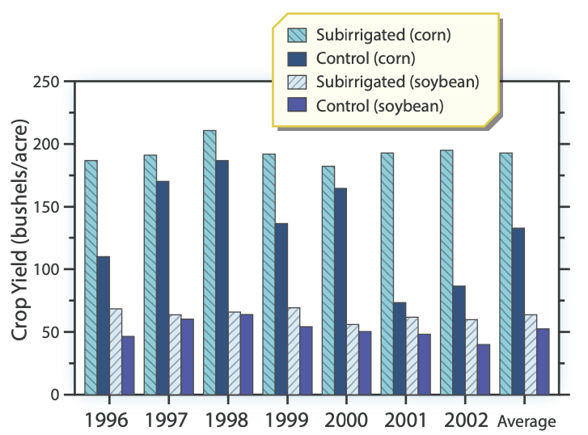

Figure : Crop yield for corn and soybeans, with and without subirrigation using a drainage recycling system. (From Christianson, L.E., J. Frankenberger, C. Hay, M.J. Helmers, and G. Sands 2016)

In this bar graph the y-axis represents the crop yield in bushels per acres, and the x-axis represents the year. The bar graph shows two different cropping systems and their performances. The control represents the traditional farming practices and the sub irrigated represents that use of the recycled runoff. Between 1996 and 2002 the sub irrigated corn crops had much more yield than did the control. In 2001 and 2002, the difference was even more dramatic, because the corn yield about twice the control. Which expresses how effective the systems can be. In terms of the soybean crops, the difference is not as dramatic, however there was not a single year where the sub irrigated crop was less than the crop. On average it is clear that if a suitable farmer were to apply this system, their yield would in no doubt increase, while indirectly decreasing the nitrate pollution rate.*:*

*Controlled Drainage:*

To understand how controlled drainage work it is important to understand how conventional drainage works. There is tube like structures that are formally known as tiles, which are put into the soil. These tiles are meant to regulate the level of water that is in the soil. There is a common rule that there should be 25% water, 25% air, and 50% soil.[20] With this being said, the way it reduces the nitrate runoff is through maximizing the amount of water that is in the soil in the first place. In terms of the controlled drainage, there is an adjustment aspect. The water drainage has different level that could either raise the water level or lower it. In the Figure, it shows the different gates and points to where the farmer can control them.

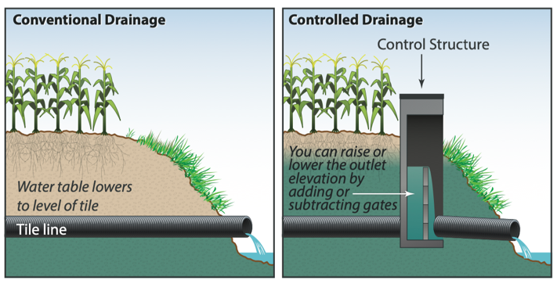 Since conventional drainage systems are common, the addition to this control structure is a relatively easy addition. After applying the system, through research, there was net decrease in nitrate loads of approximately 30%.[21] How this happens is from straining the nitrogen into the soil and

Figure : Drainage water management, also known as controlled drainage, uses control structures to retain drainage water in the soil during periods of the year when drainage is less critical (From Christianson, L.E., J. Frankenberger, C. Hay, M.J. Helmers, and G. Sands, 2016)

controlling drainage during dryer seasons.[22]

During dryer seasons the use of drainage may be unnecessary, and in some cases it would be detrimental. This could result in a waste of water due to the fast that the water might pass through the soil without fully being realized. This shows the use of keeping the water in the soil so that it could be strained into the soil. Straining improves many aspects, such as reduction of nitrate, drainage outflow reduction and even crop yield. In the graph below a few states have shown a lot of positives. In terms of the reduction of nitrate, in Figure* it shows a huge improvement in the reduction. The reason might be from the fact that conventional drainage systems previously released water at will. As a result of controlling the drainage, it seems that farmers have more control.

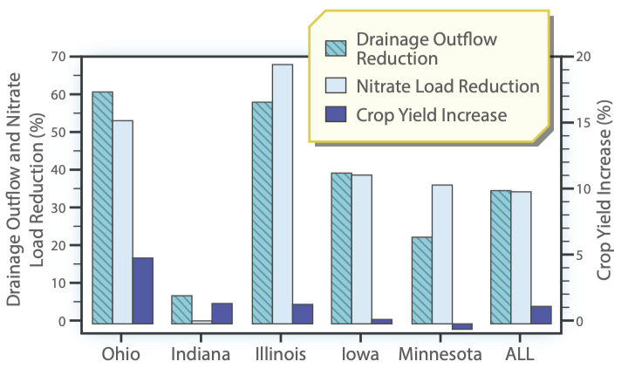

Figure : Average drainage flow and nitrate load reduction (left axis) and crop yield impact (right axis) due to controlled drainage (ADMC and NRCS, 2013).

One could question however, that this system alone is not enough to combat nitrate waste during wet conditions. The drainage system regardless of the type would be detrimental. For example, if the controlled drainage was not set at an optimal level, it would either destroy the crops from flooding or deprive it of enough water. By complementing this system with another, such as recycling at a reservoir. It could be a huge advantage.

*Bioreactors:*

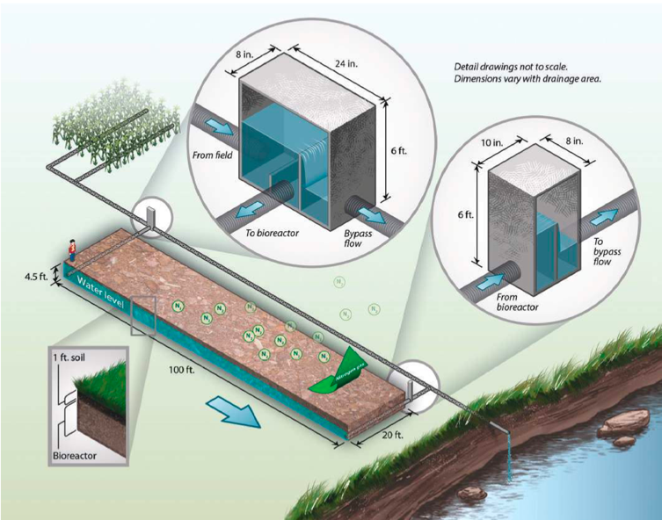 Among all of the innovations bioreactors shows an interesting way of combining water filtration and farming. The process requires a small strip of land that is filled with carbon or woodchips, that will act within the tiles or trenches. However, before the nitrate water reaches the reactor is must pass through controlled drainages. They have an that allows water in, some water that does not reach the bioreactor, and some that does.[23]

Figure : Denitrification bioreactors are an edge­of­field water quality improvement option that enhances the natural process of denitrification (from Christianson and Helmers, 2011). This illustration shows only one orientation of a bioreactor by a field; a bio, (From Christianson, L.E., J. Frankenberger, C. Hay, M.J. Helmers, and G. Sands 2016)

This is meant to prevent overflow within the

drainage system. When the nitrate is filtered

out the water it sits in the area, until it turned into gas. The positives of this method are that along with other systems it could pose as a complement to what is already in the farmers field. The addition is at the expense of a strip of land; however, its application requires little effort compared to applying a new drainage system. However, the drainage system that that is used, only filters a small amount of the nitrate water. It would seem that this was in order to compensate for the potential flooding within the system, due to the fact, that it takes time for the water to pass through the bio reactor. Another issue that one might have is the fact that the end result of the bio reactor is the nitrate turning into gas. This reduces the pollution of nitrate in runoff; however, it may be introducing another issue. In its gaseous state nitrate is not any safer, whether that be for the farmer or the atmosphere. Nevertheless, the effectiveness in reduce nitrogen runoff is evident. In the graph below the different concentration levels of the nitrate in the farm runoff was monitored. Between Jan 09 and Sep 09, the concentration rates for the inlets were always higher than the outlets. This suggests the bio reactors separated a large portion of the nitrate from entering the water ways.

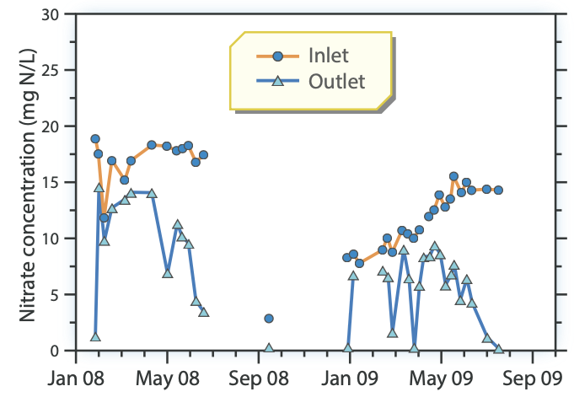

Figure 11: Nitrate -N concentration before and after passing through a bioreactor (From Woli et al, 2010)

***Conclusion:***

With different types of solutions to reduce nitrate, comes with the burden of making a decision. In some of the management practices there was a emphasis on re applying the nitrate that is lost in the process of growing the crops. However, in most cases this requires a bit more effort and money. Farmers would have to consider whether the benefits of reapplying the nitrate water is worth the cost. Convincing them may even be a hurdle on its own. In terms of the other management practices. The nitrate reduction is primarily from either a manipulation of drainage or sending the nitrate solute to another area. These methods seem extremely promising, however it may by difficult to control the different drainage systems. During wet season it may be almost damaging to have a drain gage system. Along with the fact that an overload could render the system meaningless. Nevertheless, I think that the application of different water filtration systems for their respective lands is the only way to make consistent and substantial progress towards ending nitrate pollution.

Work Cited

Christianson, L.E., J. Frankenberger, C. Hay, M.J. Helmers, and G. Sands, 2016. Ten Ways to Reduce Nitrogen Loads from Drained Cropland in the Midwest. Pub. C1400, University of Illinois Extension.

Fertilizer 101: The Big 3 - Nitrogen, Phosphorus and Potassium. (2016, October 31). Retrieved January 11, 2021, from <https://www.tfi.org/the-feed/fertilizer-101-big-3-nitrogen-> phosphorus-and-potassium

Lucas, M. D., R. M. Ross, & A. N. Swaby (eds.), 2014, The Teacher-Friendly Guide to the Earth Science of the Midwestern US. Paleontological, Research Institution, Ithaca, New York.

Andresen, J., S. Hilberg, K. Kunkel, 2012: Historical Climate and Climate Trends in the Midwestern USA. In: U.S. National Climate Assessment Midwest Technical Input Report. J. Winkler, J. Andresen, J. Hatfield, D. Bidwell, and D. Brown, coordinators. Available from the Great Lakes Integrated Sciences and Assessments (GLISA) Center, <http://glisa.msu.edu/docs/NCA/MTIT_Historical.pdf>.

Nitrogen Cycling in Agriculture: Cooperative Extension: University of Delaware. (n.d.). Retrieved January 11, 2021, from <https://www.udel.edu/academics/colleges/canr/cooperative-extension/fact-> sheets/nitrogen-cycling-in-agriculture/

1. Fertilizer 101: The Big 3, Nitrogen, *Phosphorus and Potassium* (2016, October 31, Retrieved January 11, 2021), from https://www.tfi.org/the-feed/fertilizer-101-big-3-nitrogen-phosphorus-and-potassium.
2. IBID
3. Lucas, M. D., R. M. Ross, & A. N. Swaby (eds.), 2014, *The Teacher-Friendly Guide to the Earth Science of the Midwestern US. Paleontological*, Research Institution (Ithaca, New York), ppg.148
4. IBID,148
5. IBID, 149
6. Andresen, J., S. Hilberg, K. Kunkel, 2012: Historical Climate and Climate Trends in the Midwestern USA. In: U.S. National Climate Assessment Midwest Technical Input Report. J. Winkler, J. Andresen, J. Hatfield, D. Bidwell, and D. Brown, coordinators. Available from the Great Lakes Integrated Sciences and Assessments (GLISA) Center, <http://glisa.msu.edu/docs/NCA/MTIT_Historical.pdf>, ppg.9
7. Nitrogen Cycling in Agriculture: Cooperative Extension: University of Delaware. (n.d.). Retrieved January 11, 2021, from https://www.udel.edu/academics/colleges/canr/cooperative-extension/fact-sheets/nitrogen-cycling-in-agriculture
8. Nitrogen Leaching Potential. (2019, July 17). Retrieved January 11, 2021, from https://cropwatch.unl.edu/nitrogen-leaching-potential
9. IBID
10. Christianson, L.E., J. Frankenberger, C. Hay, M.J. Helmers, and G. Sands, 2016, *Ten Ways to Reduce Nitrogen Loads from Drained Cropland in the Midwest* (Pub. C1400), University of Illinois Extension, ppg.5
11. IBID, 6
12. IBID, 15
13. IBID, 16
14. Christianson, L.E., J. Frankenberger, C. Hay, M.J. Helmers, and G. Sands, 2016, *Ten Ways to Reduce Nitrogen Loads from Drained Cropland in the Midwest* (Pub. C1400), University of Illinois Extension, ppg.16
15. IBID, 16
16. IBID, 16
17. IBID
18. IBID
19. IBID, 28
20. IBID, 22
21. IBID, 22
22. IBID, 23
23. IBID, 30 -31